Docker Introduction & Architecture
Docker has revolutionised the way software is developed, shipped, and deployed. It simplifies the process of creating, running, and managing applications by using containerization. In this blog, we'll explore what Docker is, its architecture, and how it can be used in real-world scenarios to solve everyday problems in software development and deployment.
Introduction:
Lets consider an example, we are developed an application which is running on Dev environment but not in Prod servers. So here one of the major problem is Dependencies.
For example, dev team developed a Java application and their systems has all required modules and dependencies which are used to run the application. But Those dependencies are not installed on production servers. In this case we cant able to run the applications on Prod servers.
To avoid these kind of issues, we started implementing containerization. Containerization is a process of packing the application along with its dependencies.
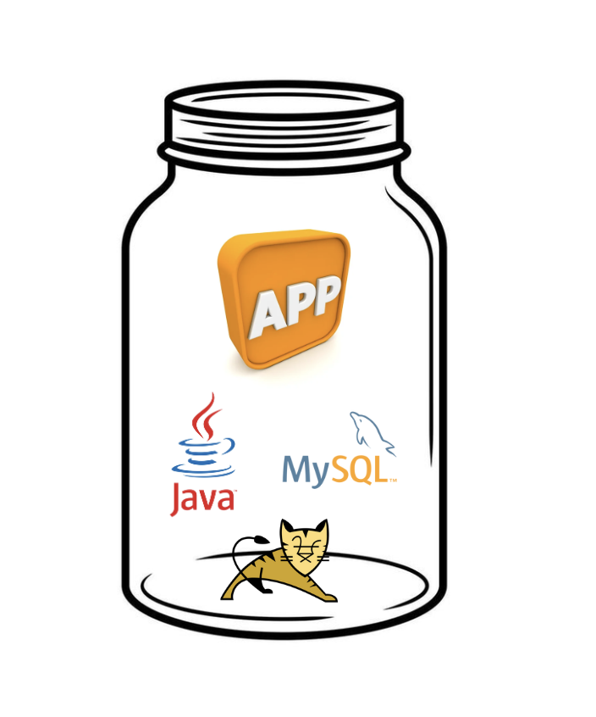
To implement containerization, there are lot of tools like Docker, Podman and LXC/LXD. Out of these Docker is the best tool to create containers.
Docker:
Docker is an open-source platform that allows developers to build, package, and run applications in containers. Containers are lightweight, standalone, and executable units that include everything needed to run a piece of software: code, runtime, libraries, and dependencies.
Why Use Docker?
- Consistency: Docker ensures that our application runs the same way everywhere (Dev, Test and Prod)
- Efficiency: Containers use fewer resources than traditional virtual machines, as they share the host operating system's kernel.
- Speed: Containers start almost instantly, making development and deployment faster.
- Scalability: Docker makes it easy to scale applications horizontally by spinning up more container instances.
Keywords in Docker:
Containers:
- A Docker container is a lightweight, standalone, and executable software package that encapsulates an application and all its dependencies, including the operating system, libraries, and runtime environment.
- Containers created from a Docker image and can be run on any machine that has Docker installed, providing a consistent and isolated environment for the application to run.
Images:
- A Docker image is a read-only template that contains a set of instructions for creating a container that can run on the Docker platform.
- It provides a convenient way to package up applications and all the dependencies.
- We can store these images on registry either publicly or privately.
Registry:
- A Docker registry is a repository for storing and sharing the docker images. Docker is configured to pull the images from Docker Hub by default, but organisations often use private registries for their projects like ECR, ACR, GCT etc…
How it works: 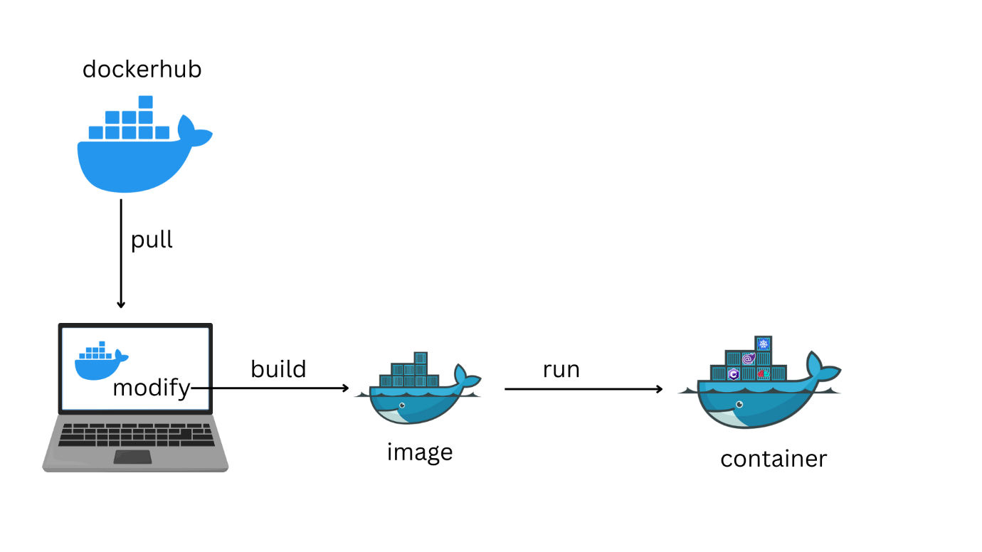

First we need to pull the base image from registry and make some modification using Dockefile. Once we build the Dockerfile, it will create docker image and we can run the image to create a container.
NOTE: To create a container, we need image.
Docker Architecture:
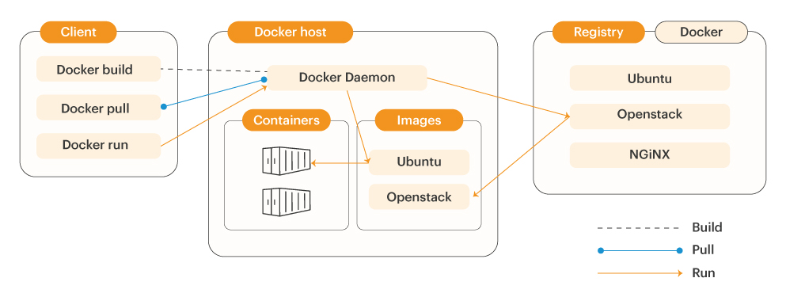
Docker architecture majorly contains this 3 components
- Client
- Host
- Registry
- Docker Client: The Docker client is used by users which interact with Docker, when we use such commands to create a container, start the container or delete the container, the client sends these commands to Docker Daemon to perform that particular action.
- Docker Host: It is a system where we installed a docker. Ex: EC2 instance, Azure VM, Personal Lappy etc..
- Docker Registry: It is used to store and share the docker images. In registry we can store our images on public or private.
Conclusion
Docker has become an indispensable tool in modern software development and deployment. By understanding its architecture and leveraging its features, teams can build, ship, and run applications more efficiently and consistently. Whether you're a developer, DevOps engineer, or IT professional, learning Docker is a step toward mastering containerization and revolutionizing how you handle applications.
Happy Dockering!
If you found this blog helpful for your interviews or in learning Docker troubleshooting, please hit a heart for 10 times and drop a comment! Your support motivates me to create more content on DevOps and related topics. ❤️

Todays Commands:

yum install docker -y

2 docker version

3 systemctl status docker

4 systemctl start docker

5 systemctl status docker

6 docker version

7 docker pull shaikmustafa/paytm:bus

8 docker images

9 docker run -d --name bus -p 1431:80 shaikmustafa/paytm:bus

10 docker ps

11 docker logs bus

12 docker ps

13 docker pull shaikmustafa/paytm:movie

14 docker images

15 docker run -d --name movie -p 1111:80 shaikmustafa/paytm:movie

16 docker ps

17 docker pull shaikmustafa/paytm:bank

18 docker images

19 docker run -d --name bank -p 2222:80 shaikmustafa/paytm:movie

20 docker ps

21 docker rm bank

22 docker stop bank

23 docker rm bank

24 docker ps

25 docker run -d --name bank -p 2222:80 shaikmustafa/paytm:bank

26 docker ps

27 docker stop movie

28 docker start movie

29 docker stop bank

30 docker start banl

31 docker start bank

32 docker images

33 history

Interview questions

1.What is Docker ?
Docker is an open-source containerization platform that allows developers to package applications along with their dependencies into lightweight, portable containers. These containers can run consistently across different environments like development, testing, and production.
Unlike virtual machines, Docker containers share the host OS kernel, making them faster and more resource-efficient. Docker helps solve the ‘it works on my machine’ problem by ensuring environment consistency. It also supports microservices architecture, making it easier to build, deploy, and scale applications.

2. What is Containerization ?
Containerization is a technique where an application and all its dependencies—such as libraries, configuration files, and runtime—are packaged together into a single unit called a container. This ensures that the application runs consistently across different environments like development, testing, and production.
It is lightweight because containers share the host operating system’s kernel, making them faster and more efficient than traditional virtual machines. Containerization is commonly implemented using tools like Docker.

3.Diff between vm and container?
Virtual machines and containers are both virtualization technologies, but they work differently. Virtual machines virtualize the hardware and run a complete guest operating system on top of a hypervisor like VMware. This makes them heavier and slower to start.
Containers, on the other hand, virtualize the operating system. They share the host OS kernel and run lightweight, isolated applications using tools like Docker. Because of this, containers are faster, more efficient, and ideal for modern DevOps and microservices architectures.
For example, if I need to run different operating systems like Linux and Windows, I would use VMs. But if I want to deploy multiple microservices quickly and scale them, I would use containers.

4.what is docker image?
A Docker image is a read-only template that contains everything needed to run an application, including the code, runtime, libraries, and dependencies. It acts as a blueprint for creating containers. Images are stored in repositories and can be reused to create multiple containers consistently across environments.

5.what is container?
A container is a running instance of a Docker image. It provides a lightweight and isolated environment where the application executes. Containers share the host OS kernel, making them fast and efficient compared to virtual machines, while still ensuring consistency across environments.

6.diff b/w container and image?
A Docker image is a static, read-only template, while a container is a dynamic, running instance of that image. The image acts like a blueprint, and the container is the actual running application. Multiple containers can be created from a single image, each functioning independently.

7.what is command to create a container?
We use the docker run command to create and start a container from an image. For example, docker run -d -p 8080:80 nginx runs a container in detached mode and maps ports. If the image is not available locally, Docker will automatically pull it before creating the container.

8.what is command to pull the images?
The command to pull an image from a repository like Docker Hub is docker pull <image_name>. For example, docker pull nginx. This downloads the image locally so that we can use it to create containers.

9.how to see running containers?
To view running containers, we use the docker ps command. It shows details like container ID, image name, status, and ports. If we want to see all containers, including stopped ones, we use docker ps -a.

10.how to check container logs?
We use the docker logs <container_id> command to check the logs of a container. It helps in debugging and monitoring application output. We can also use options like -f to follow logs in real time.

